**Name:** Senny Huang **Date:** 10/21/2021

**Lab section:** Thursday – Section 9

**Show your work!!!**

**Acquire**

Week: 1

Date: Jan 1 Year: **2018** Data: <https://data.world/makeovermonday/2018-w-1-u-s-per-capita-consumption-of-poultry-livestock>

Source Article/Visualization:

U.S. Per Capita Consumption of Poultry and Livestock   
Data Source: [National Chicken Council](http://www.nationalchickencouncil.org/about-the-industry/statistics/per-capita-consumption-of-poultry-and-livestock-1965-to-estimated-2012-in-pounds/)

**Represent**

**Critique**

I do not like how there are no labels on either of the axis.

**Mine**

How much is red meat consumed in the United States?

**Filter**

**Show** (display, list, make it visible) the filtered data.

**Stakeholders**

* Who is your audience?

Researchers or people (specifically life stock owners) interested in the number of red meats consumed over the span of a number of years.

* What assumptions did you make?

The audience knows what red meat is. The audience can read numbers. The audience is looking for specifically 1960 through 2018.

* What visualization tool/software did you use?

Tableau

**What to submit:** This document in PDF format only (if you do not know how to do this, ask).

**Choose the best layout** for your makeover visualization

* Portrait or Landscape
* Remove the page of the layout that you DO NOT choose. No blank pages!

**Refine (Makeover – Portrait View)**

Use an additional page if necessary. Remember, the purpose of visualization is “insight.” Take and include a screenshot of your visualization and include it below. Use Data Visualization Best Practices (see data

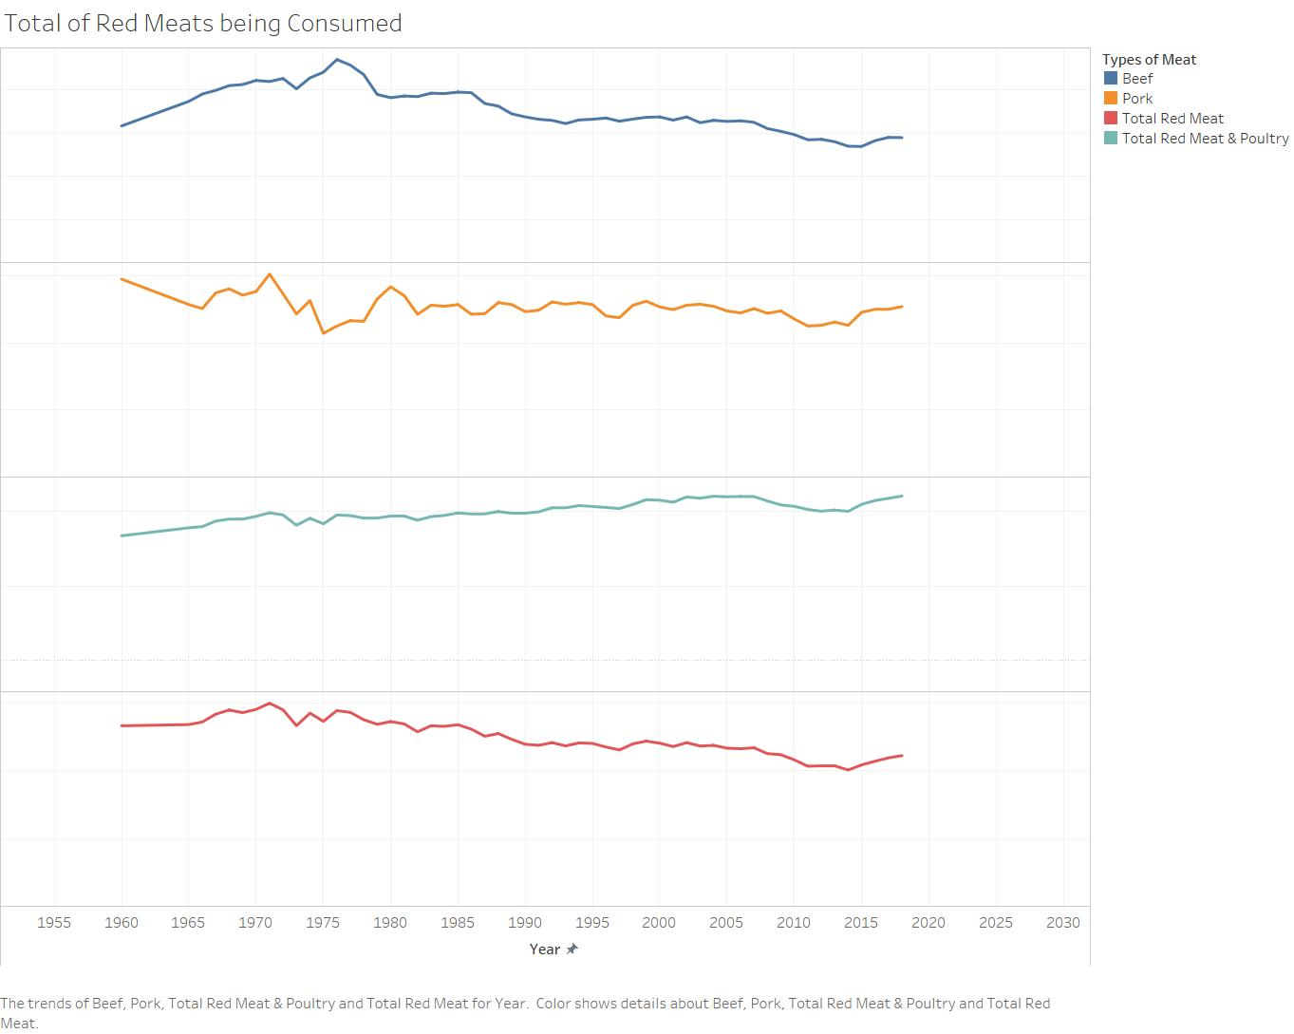

**Resources**

Data Visualization Checklist:

<http://stephanieevergreen.com/wp-content/uploads/2016/10/DataVizChecklist_May2016.pdf>

How to give constructive criticism:

<https://personalexcellence.co/blog/constructive-criticism/>

Sample Makeovers

<https://www.makeovermonday.co.uk/gallery/>

**Grading Rubric**

|  |  |  |  |
| --- | --- | --- | --- |
| **Excellent**  **(21-25 pts)** | **Good**  **(10-20 pts)** | **Fair**  **(5 – 9 pts)** | **Needs Improvement (0 – 4 pts)** |
| Meets **ALL** or most of these: Makeover is esthetically pleasing (color, perception), best practices followed (insightful), Correct dataset downloaded; provided an interesting point of view of the data; critiqued previous makeover, critique is constructive (indicates one thing that is done well, and one thing that could be done differently, what will be done to improve the visualization), assumptions (more than one) are listed. | Meets **MOST** of these: Makeover is esthetically pleasing (color, perception), best practices followed (insightful), Correct dataset downloaded; provided an interesting point of view of the data; critiqued previous makeover, critique is constructive (indicates one thing that is done well, and one thing that could be done differently, what will be done to improve the visualization), assumptions (more than one) are listed. | Consistently meets **SOME** of these: Makeover is esthetically pleasing (color, perception), best practices followed (insightful), Correct dataset downloaded; provided an interesting point of view of the data; critiqued previous makeover, critique is constructive (indicates one thing that is done well, and one thing that could be done differently, what will be done to improve the visualization), assumptions (more than one) are listed. | Little to no evidence of the understanding of the data visualization process.  Lackluster makeover or no makeover.  Little effort. |